

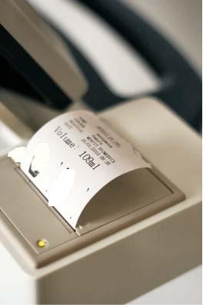

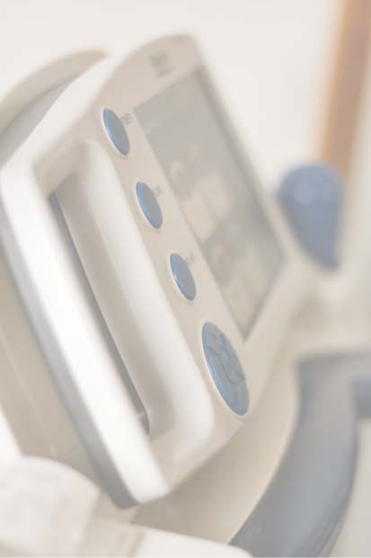
care.
%
^f
4

Thescannercanbeoperatedinmanyways:

•initsleathercaseorflightcase.

•initsdockingcradleonatrolleyordesk

•initswallmountedcradle

To print results, the scanner is placed in its cradle and if required can stay there

during use. More conveniently the results can be sent via its USB port to any

suitabledevice.ThePalmBladderScannerisahandhelddeviceandtheperfect

answer for easy transportation between different hospital locations or for use

in primary care environment such as a continence service delivering home

Technical Specification for Palm Bladder Scan

Scan method: 3D Mechanical sector scanning

Probe freq.: 2.6 MHz central freq.

Scan depth: 180mm

Swing angle: 120 degree

Rotating angle: 180 degree

Screen size: 7 inches TFT color LCD

Feature/Functions: Real-time pre-scan function for bladder location /
Sound alarm function /

Bladder image and volume display / Scanned image storage / Software upgrade through USB / Printer

build in cradle / Battery consumption management

Max.volume Measuring: 999ml

Difference: ±20% (Volume 150ml)
±15% (Volume > 150ml)

Working environment: Temp. +5 ~ +40 Humidity ≤ 80%

Atmosphere pressure: 700hpa-1060hpa

Power supply: Rechargable lithium aggregation battery

Battery capacity: 6300mAh

Charging method: AC Adapter, mobile charger

Input for AC adapter:
220V±10% 50/60Hz

Instrument dimension: 32cm x 17cm x 5cm

Weight: 2kg

Accessories: Trolley or wall-docking station Aluminium look case or

leather case for PBS Delivered With batteries (2x) and charger

